Having a Say’s Got Talent

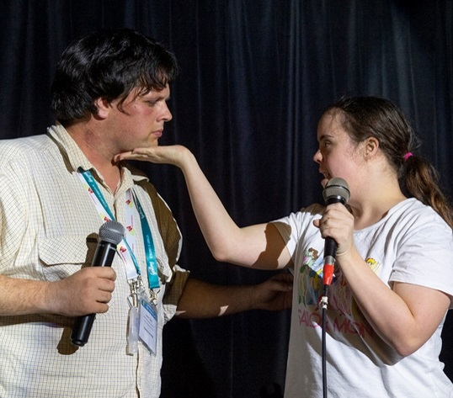
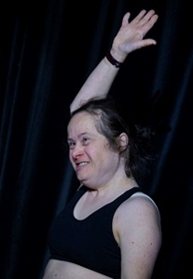
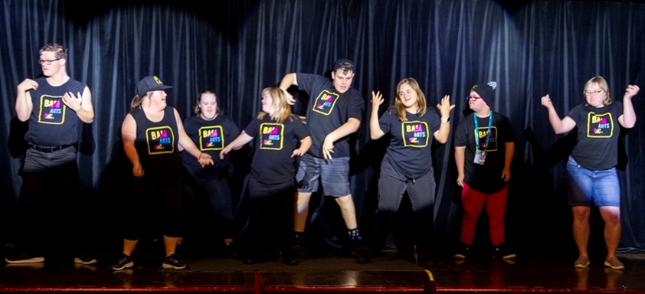
Auditions will be held on

Monday 5th Feb. 2024

Starting at 7.00pm

Luxor Lounge, Sphinx Hotel
2 Thompson Road,
North Geelong

All performers must be signed up by Friday 19th Jan., 2024
to be eligible to audition on the night.

Registrations will not be
accepted on the night!

Important: Please read conditions of entry on next page

Only
20 places
available

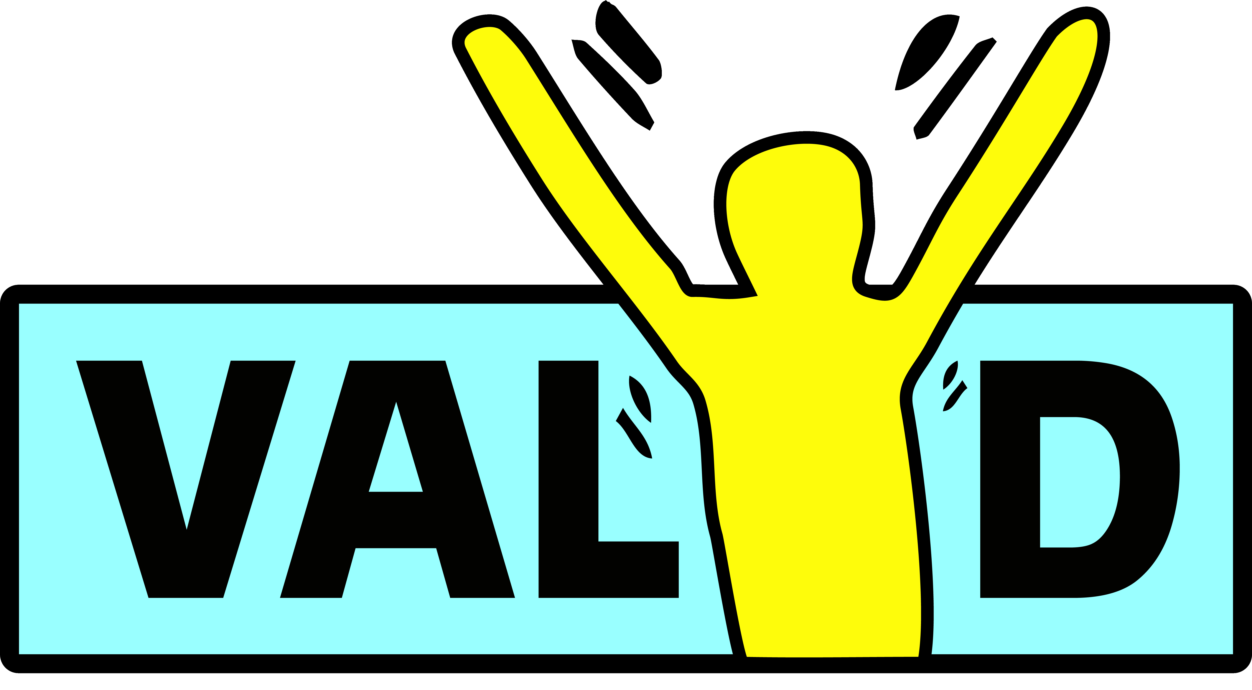
Performer’s Name: |  | Click or tap here to enter text.
Address: |  | Click or tap here to enter text. |  |  |  |  | Postcode: |  | Click or tap here to enter text.
Contact Person: |  | Click or tap here to enter text.
Phone: | Click or tap here to enter text. |  |  |  | Email: | Click or tap here to enter text.
Do you have any specific mobility needs e.g. wheelchair access to the stage? (please tick) |  |  |  |  |  |  |  | Yes |  | ☐ | No | ☐
Type of performance  (e.g. singing, dancing, comedy) |  |  |  | Click or tap here to enter text.
Click or tap here to enter text.
Name of performance? |  |  | Click or tap here to enter text.
Please return form to VALID, 34 Stanley Street, Collingwood Vic. 3066
or Email to: havingasay@valid.org.au



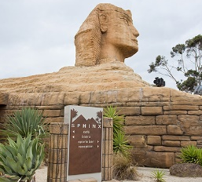


HaS’s Got Talent Conditions of Entry

1. Entry is open to people with disability that are registered (including online delegates) to attend the Having a Say Conference 2024.
2. Please send this entry form to VALID no later than the 19th Jan. 2024 as only acts registered by then will be eligible to perform on the audition night.
3. The winner of the last Red Faces competition cannot enter the competition this year (ie: if you won in 2023 you cannot enter the competition in 2024 – will have opportunity to perform in main session).
4. A maximum of 3 acts are eligible to enter the competition from each service/organisation. (If you have more than 3 acts who want to audition, why not have your own Talent Competition?)
5. A maximum of 20 acts will perform at the auditions on Monday evening, 5th Feb. The 3 finalists of the auditions will perform at the closing ceremony on Tuesday 6th Feb. in Costa Hall at 3.15pm.
6. Please cancel if you have Covid or are unwell.
7. If you are using music in your performance you must bring a CD/USB to the auditions. Please put your name on it so VALID can return it to you.
8. If you require a musical instrument or other equipment then you will need to bring your own as VALID is not able to provide instruments.
8. Check in with Jon by 6.30pm on the night - auditions start at 7.00pm
9. VALID will send you a confirmation letter, if you do not receive a letter saying you are booked in, please contact VALID.
10. Jon will contact you the week before the conference to confirm all the details of your performance.
11. The Red Faces Talent Show will be held in the Luxor Lounge at the Sphinx Hotel, 2 Thompson St, North Geelong. You can contact the Sphinx Hotel on ph: 03 5278 2911.
12. Booking a table is recommended in the Bistro ph: 03 5278 2911 or
food is available from the Bain-Marie at the service area near the entry to the Luxor Lounge. Get there early to get a good seat/table.
For more information about
Having a Say’s Got Talent or the Having a Say Conference
phone Chris 0475 698 884 or Jon at VALID (03) 9416 4003
website: www.valid.org.au or email: havingasay@valid.org.au

