

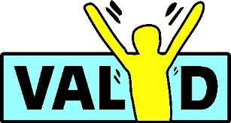


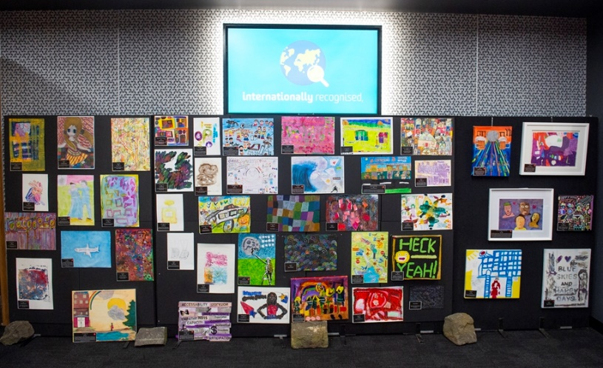
Victorian Senior Practitioner

Thank you to the sponsor of the Art Competition the Victorian Senior Practitioner.
Conference Theme: The Future is Ours!

The Having a Say Conference is back in 2024!

The disability community has had some hard times over the last few years – but we have come together to make positive change.

People with disability have shared a lot about their experiences this year. The Disability Royal Commission (DRC) and the NDIS Review have been listening. We now look forward to their ideas to make things better.

Come and join us for the Having a Say Conference ‘The Future is Ours’! It’s going to be a wild ride!

Having a Say presents the
Barbara Donovan & Sarah Guilfoil
Art Competition
5 – 6 February 2024
Deakin University, Waterfront, Geelong




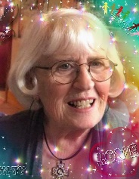
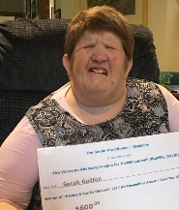

About Barbara Donovan & Sarah Guilfoil

The Art Competition has been named in memory of Barbara Donovan who was a Life Member of VALID and other Geelong organisations. She volunteered at the Having a Say conference for over 10 years and worked for people with disabilities over the last 50 years. Sadly, Barbara’s daughter Sarah Guilfoil passed away in May 2020. Sarah has won the Art Competition several times. The HaS Art Competition is now named in remembrance of both Barbara and Sarah.
Barbara Donovan & Sarah Guilfoil Art Competition
Who can enter the competition?
• Three prizes will be awarded to people registered to attend the HaS conference
• Two prizes will be awarded to non-registered conference artists
• Entry is available only to people with a disability

Conditions of Entry
• The artwork is to be based on the conference theme: The Future is Ours!
• Only one entry per person
• We accept paintings and drawings but not photographs
• Put your name and contact details on the back of your artwork
• Entries will not be accepted at the Conference
• Artwork is to be approximately A3 size (NO larger than 40cm x 50cm)
Please note: Large works of art may be photocopied and displayed in A3 format.
• You release VALID from liability for any loss or damage in relation to your artwork
• The prize money is a ‘payment’, so all winning artworks become the property of the conference sponsor (VSP) and the winning artists agree to give the Senior Practitioner exclusive rights to use the artwork in their publicity and promotional materials – for example, brochures, newsletters, etc.
• Artists give VALID permission to use their artwork in VALID publicity and promotional material and also to promote the art competition for future Having a Say Conferences
• VALID staff, family members and organisers of the Having a Say Conference, including the Local Reference Committee, are not permitted to enter the competition but may display their artwork
• Artwork will be on display at the conference as well as on our online competition

Sponsor
Thank you to the Victorian Senior Practitioner for their continued support of the Art Competition. Under the Disability
Act 2006 (Vic), the Victorian Senior Practitioner’s role is to protect people with disability and make sure staff and services provide good quality support.
Prizes
The five winning entries selected will receive a cash prize and certificate:
1. Conference delegates - The three winning entries will be awarded a cash prize of $600 and a certificate
2. Non conference entry - The two winning entries will receive a cash prize of $350 and a certificate
3. The winners will be presented with the prizes at the closing Ceremony in Costa Hall at the Having a Say Conference
When can you collect your Artwork?
• Artwork, other than the winning entries on display at the conference, may be collected after the Closing Ceremony on Tuesday 6th February 2024.
Please Note: You cannot take your artwork from the display. A VALID staff member will hand out the artwork.
• All other artwork can be collected at the VALID office after the conference.
Note: Artwork not collected within 3 months of the conference becomes the property of VALID

Send VALID the following things:
• your artwork and a signed entry form (pages 3 & 4)
• a photo of yourself
• a short bio about yourself, including what you like about doing art

Post to VALID at: 34 Stanley St, Collingwood 3066 &/or
email: havingasay@valid.org.au no later than 22nd December 2023



Tell us about your art and what inspired you
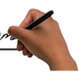
Title: Click or tap here to enter text.
Description:
Click or tap here to enter text.

Application Form
Your Name: Click or tap here to enter text.
Address: Click or tap here to enter text. |  | Postcode click
Telephone: Click or tap here to enter text. | Mobile: Click or tap here to enter text.
Email: Click or tap here to enter text.
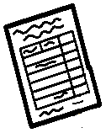
Contact Person: Click or tap here to enter text.
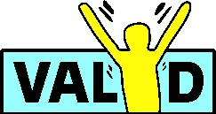
Need more information contact:
VALID
34 Stanley Street, Collingwood VIC 3066
Phone: 03 9416 4003 Email: havingasay@valid.org.au

Conditions of entry
1. I have read and agree with the conditions of entry
2. If my artwork exceeds A3, I agree to have it photocopied for display as listed in the conditions of entry
3. I understand that ALL winning artworks will become the property of the Competition sponsor Victorian Senior Practitioner
4. I give VALID permission to use my artwork in the VALID Newsletter, Conference Report and in promotional material for the Having a Say Conference
5. I understand that if I do not win a prize and I do not collect my artwork from VALID within 3 months of the 2024 conference, the artwork becomes the property of VALID.


Please tell us which prize you are entering by ticking P:
☐ Registered Conference Delegate ($600)
☐ Non-registered (i.e. not attending) Conference Delegate
I give VALID permission to use my artwork in the VALID Newsletter, Conference Report and in promotional material for the Having a Say Conference
Signed: Click or tap here to enter text.
Date: Click or tap here to enter text.
Need more information contact:
VALID
34 Stanley Street, Collingwood VIC 3066
Phone: 0475 698 884 Email: havingasay@valid.org.au

