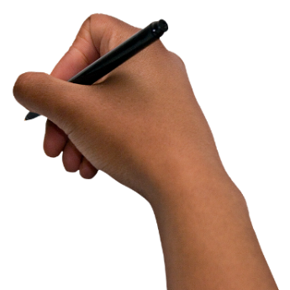
Dulcie Stone Writers Competition
Do you have a story to tell?
Are you a writer or do you draw pictures?

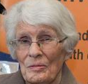
Dulcie Stone was a disability advocate from Victoria.
She was a big supporter of people with intellectual disability and writing.
VALID created the Dulcie Stone Writers Competition to remember Dulcie and to encourage people with an intellectual disability to be creative.
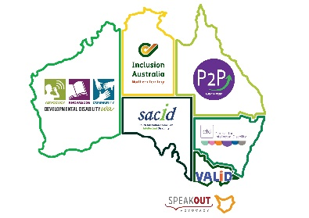
Together with Writers Victoria and Inclusion Australia we are expanding the competition so that anyone with an intellectual disability in Australia can take part.


You can choose what you want to write about
- Something important to you, like your friends and family
- Your community
- A made up story
- Or something else

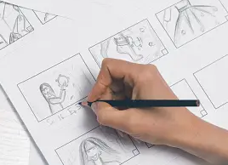
You can write a story up to 1000 words
or
make a storyboard of up to 3 pages of A4 drawings.
A storyboard is pictures or drawings that tell a story.


There is a first prize of $500.
There is also $200 for the best entry in each state!

Application Form
Name
Address
Phone Number
Email
Choose one of the following options (one choice only)
□ Written Story | Your story title:  Tell us what your story is about here:
□ Storyboard | Your story title:  Tell us what your story is about here:
Send us your story with this application form
 | Email your story and for to heather@valid.org.au
 | You can also post to:  VALID, 34 Stanley Street, Collingwood, Victoria, 3066
 | The closing date is 30 September 2023.
I give VALID permission to use my story in the VALID Newsletter, Conference Report and in promotional material for the Dulcie Stone Writers Competition.

Signed ……………………………………………………………… Date: ………………………….…….

