Position Description

Job Title: Project Officer

Location (Where you will work):

You will be working at the VALID office in Richmond.
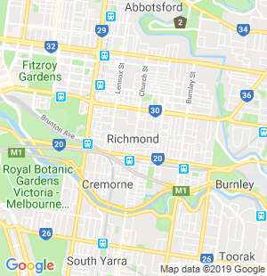
Sometimes you will need to work at other places with the project team.

Hours: 2-3 days a week until June 2022

Who you need to report to:

You will report to (title of manager).

All VALID Staff take direction from (name of CEO)

What you need to do:
You will need to work with the Project Manager on the (name of project). Tasks will include:

Preparing for and co-chairing meetings


Talking to people with a disability about (add topic)


Talking to services about (add topic)


Working together to make information about:
- (add 2-3 dot points here)

Other tasks at the direction of the Project Manager like:

Making presentations and presenting at Having a Say Conference and other conferences


Being part of consultations (feedback sessions)

Going to meetings including the staff meeting


Taking minutes for meetings


Having supervision meetings with your manager


Other things you are asked to do by the manager.

Key Selection Criteria (What you need to be able to do)


Travel to the VALID Office in Richmond independently or with the assistance of your support worker

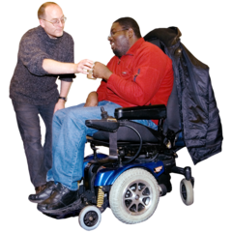

Provide a support worker if you need one




Basic reading and writing skills, (or use assistive technology to read and write)


Good communication skills



Work as part of a team

Your tasks need to be done in line with VALID Advocacy Policy, which is based on:

- VALID’s Mission Statement


- Empowering individuals with intellectual disability to exert control and influence over decisions and choices which affect their lives


- Working with those that are supporting the best interests of people with intellectual disability to be effective in their role

- A collaborative approach to project work with organisations


If you would like to know more about the job, please contact name)

Phone: (number) Email: (email address)

