This template will help you know what to talk about in supervision
- You can fill in the ‘To talk about’ column and send it template to your manager before the meeting or fill it out together
- Your manager will fill out the ‘Notes’ column at the meeting
- Your manager will send the completed template back to you after the meeting so that you can do the tasks. They will also keep it in your file.
Who is meeting? Click or tap here to enter text.
Date: Click or tap to enter a date.
Topic | To talk about | Notes
Best thing that happened this week   | Click or tap here to enter text. | Click or tap here to enter text.
Information  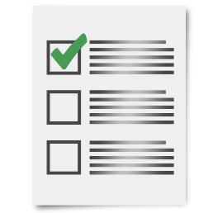 | Click or tap here to enter text. | Click or tap here to enter text.
My tasks   | Click or tap here to enter text. | Click or tap here to enter text.
My performance   | Click or tap here to enter text. | Click or tap here to enter text.
Support I need   | Click or tap here to enter text. | Click or tap here to enter text.
Things to learn   | Click or tap here to enter text. | Click or tap here to enter text.
Next meeting   | Click or tap to enter a date. | Click or tap here to enter text.
What we appreciate   | Click or tap here to enter text. | Click or tap here to enter text.
VALID developed this based on a Helen Sanderson template. Use with your workplace policies and procedures.
www.valid.org.au


